Use the following StackPanel as the content of a window.

<StackPanel Background="Orange">

<Label FontWeight="Bold" FontSize="20" Foreground="White">

WPF 4.5 Unleashed

</Label>

<Label>© 2013 SAMS Publishing</Label>

<Label>Installed Chapters:</Label>

<ListBox>

<ListBoxItem>Chapter 1</ListBoxItem>

<ListBoxItem>Chapter 2</ListBoxItem>

</ListBox>

<StackPanel Orientation="Horizontal"

HorizontalAlignment="Center" TextElement.FontSize="30"

TextElement.FontStyle="Italic">

<Button MinWidth="75" Margin="10" >Help

<Button.Style>

<Style TargetType="{x:Type Button}">

<Style.Triggers>

<Trigger Property="IsMouseOver"

Value="True">

<Setter Property="Foreground"

Value="Green"/>

</Trigger>

</Style.Triggers>

</Style>

</Button.Style>

</Button>

<Button MinWidth="75" Margin="10">OK</Button>

</StackPanel>

<StatusBar>You have successfully registered this product.</StatusBar>

</StackPanel>

Your resulting window should look like this:

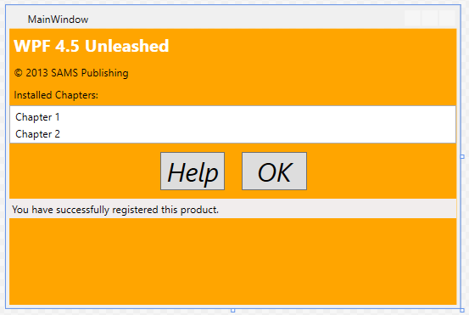

**Step 1**

Change the title bar so that in includes your name.

**Step 2**

Create a Window.Resource that contains a color. The slides show how to do this. (search for “myBrush”)

Use that resource to set the background color of the StackPanel so that it is no longer Orange. Once again, the slides show how to do this.

**Step 3**

Follow the pattern from Step 2 to move all the formatting into styles.

At this point, there shouldn’t be format information in your StackPanel nor any of its elements. You are allowed to refer the resources defined in your Window.Resource, but are not allowed to give any other style information in this part of your XAML.

Your window should still look just like the screenshot above. (You’ll have to change the color back to Orange).

**Step 4**

Cut your styles from the Window.Resource and paste them into the app.xaml file. The Window.Resource should be empty.

Your window should still look just like the screenshot above.

**Step 5**

Create a resource dictionary (Project->New Item->WPF->Resource Dictionary). Call your resource Style1.

Copy the styles from app.xaml to this resource. Delete the resources from app.xaml.

Add code to your window loader function that loads this resource. The code for doing this is at the end of the slide show.

At this point, the window won’t look right in the design window. It won’t look right until the window is loaded and your Window Loader function loads the style sheet.

**Step 6**

Add two buttons to the bottom of the window. Create two style sheets that can be loaded by pressing the two buttons. Use the mechanism from Step 5. For this to work, your style.xaml files must be part of your project, and you must not include styles in your window or app.

**Step 7**

Add two more buttons to the bottom that will load styles from XAML files that are NOT part of your project. The XAML files are formatted the same as in Step 5, but they are loaded with the following code:

ResourceDictionary resources = null;

using (FileStream fs = new

FileStream("skin1.xaml",

FileMode.Open,

FileAccess.Read))

{

// Get the root element:must be a ResourceDictionary

resources = (ResourceDictionary)XamlReader.Load(fs);

}

Application.Current.Resources = resources;

Using this mechanism, you CAN have a style sheet in the application, and you can also edit the XAML files while your application is running, and when you reload them you will see the changes.

**Finally**

When you are done, you should have five different appearances for your window: The default from when the program loads (which should match the screenshot above), and the four from the buttons. Once you click either of the second two buttons, the first two may not work. If that’s the behavior you get, that’s OK. It comes about because the styles are loaded differently and one may hide the other.

When I grade these, I will look at three things:

1. How completely did you move all formatting to the style sheets
2. How creatively did you design/implement your style sheets
3. How well did you follow good programming practices.

I’m willing to give extra credit if you go above and beyond on your style sheets.